Setup Your Web Host

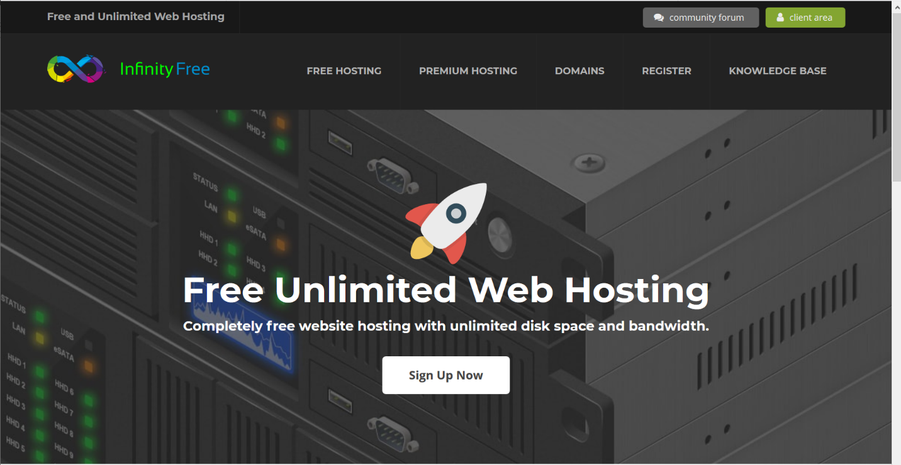

Start by going to http://infinityfree.net



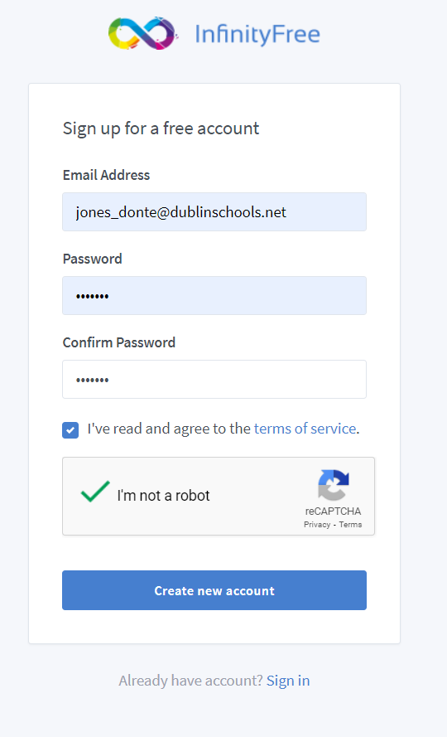

Scroll Down & Find,

Sign Up Now

Enter your details to create your account.

Verify your account After creation

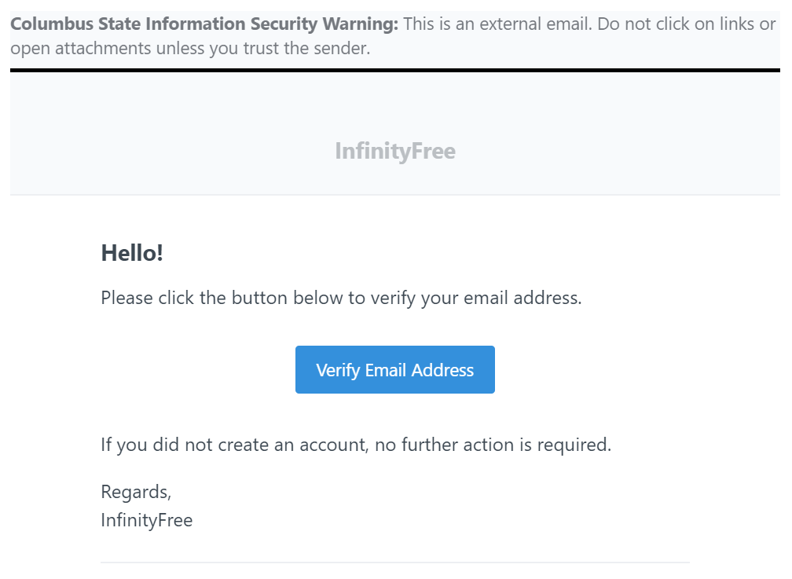



Create a site by clicking “New Account”

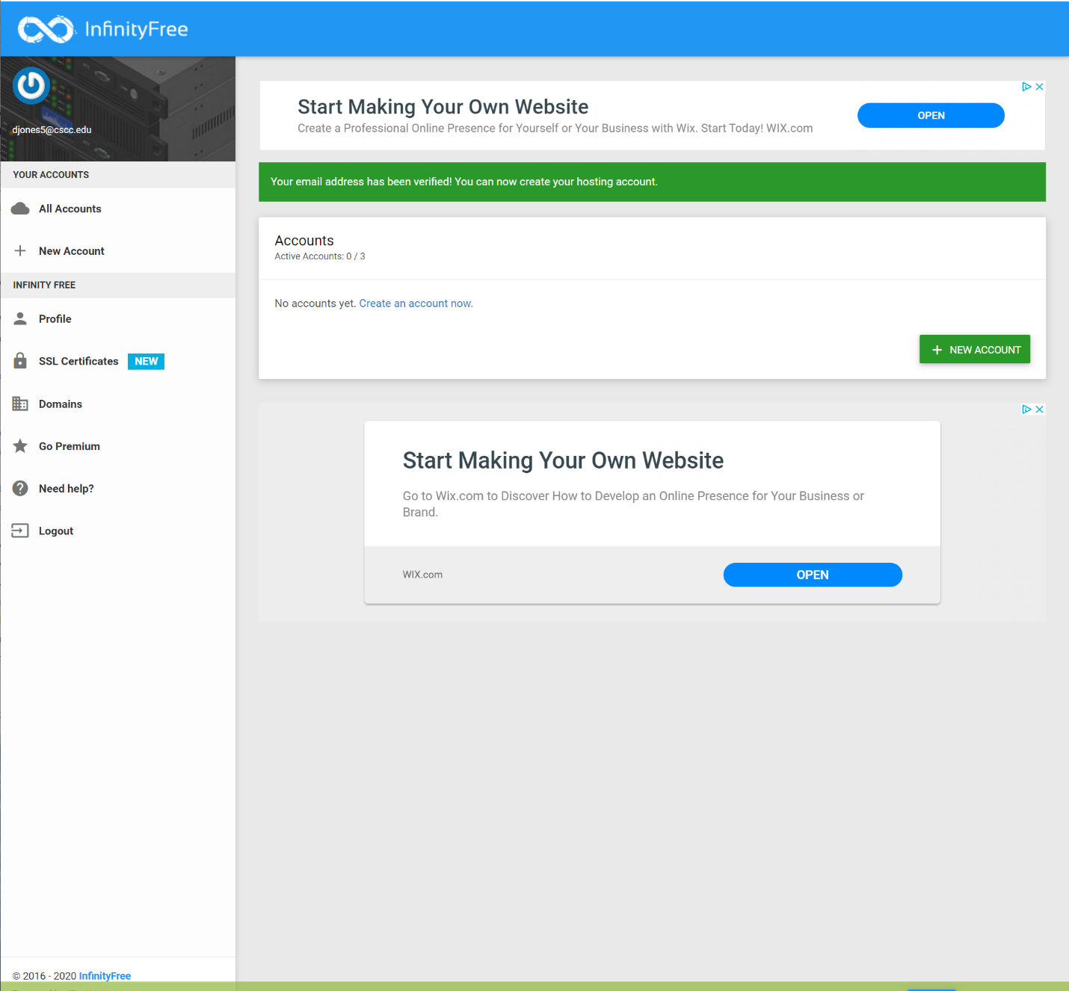



Either link will work.

Create your account/site using the following format:

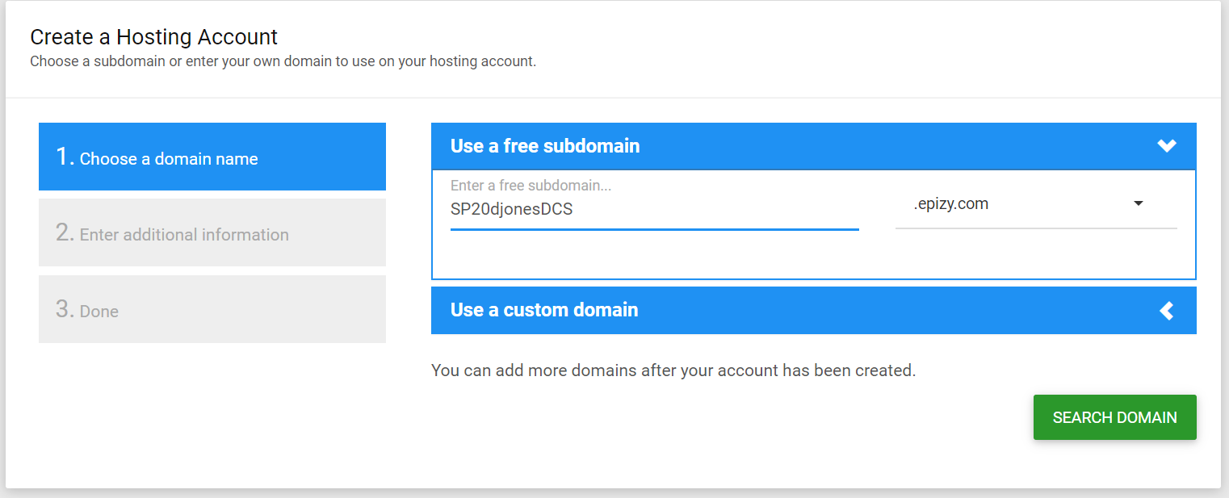



Semester Abbreviation (AU if 1st Semester or SP for 2nd Semester) | Year (two digit) | First letter of first name | Last name | DCS

\*Use the example in the image as a reference:

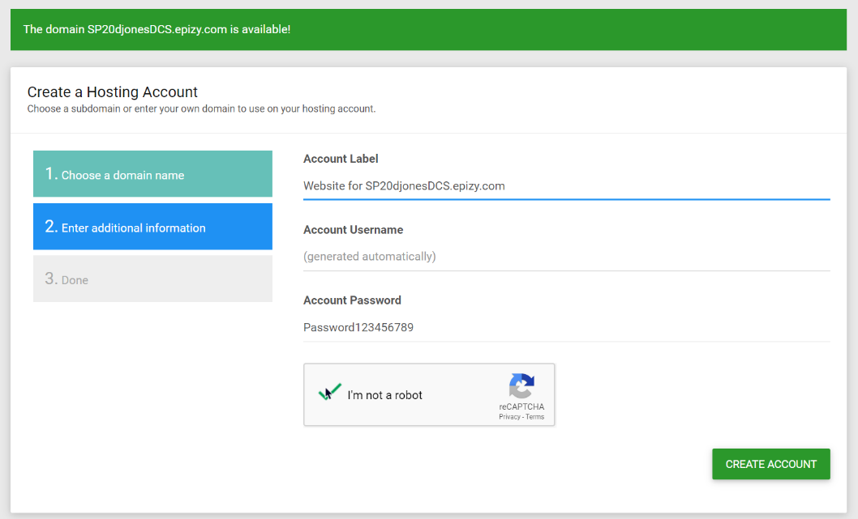

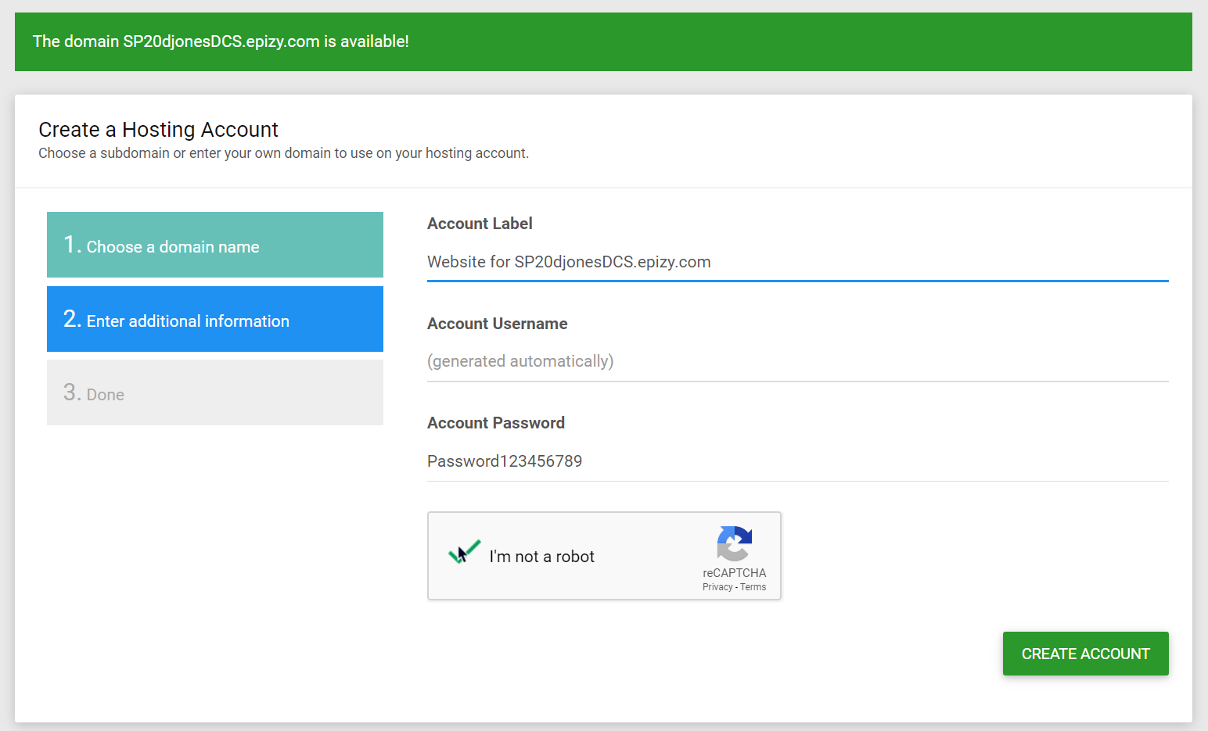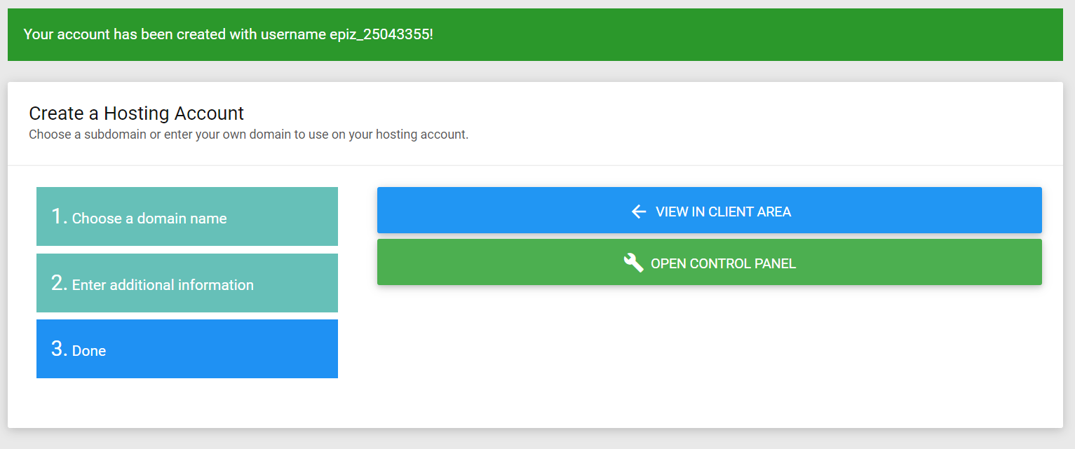

Select “Open Control Panel”

Important Notice

You should see a window like the one below, select “I Approve”

This will enable notification should your account be deactivated for inactivity or some other reason



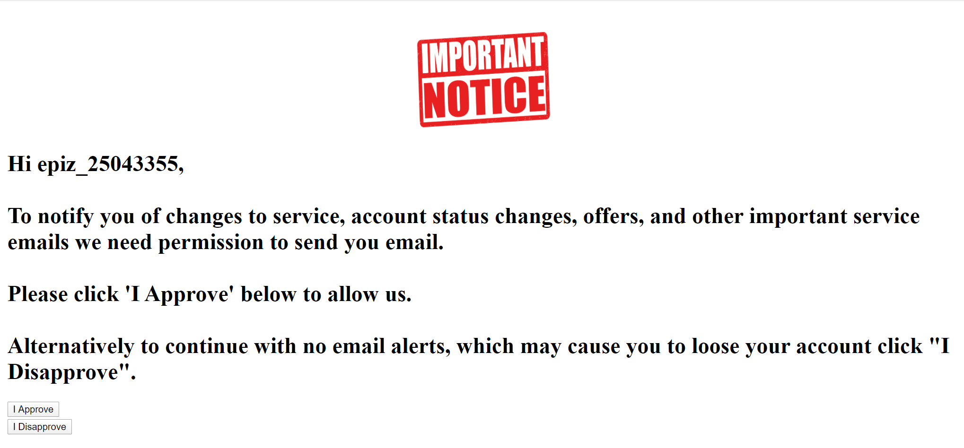

Your Console

You should be taken to the following window

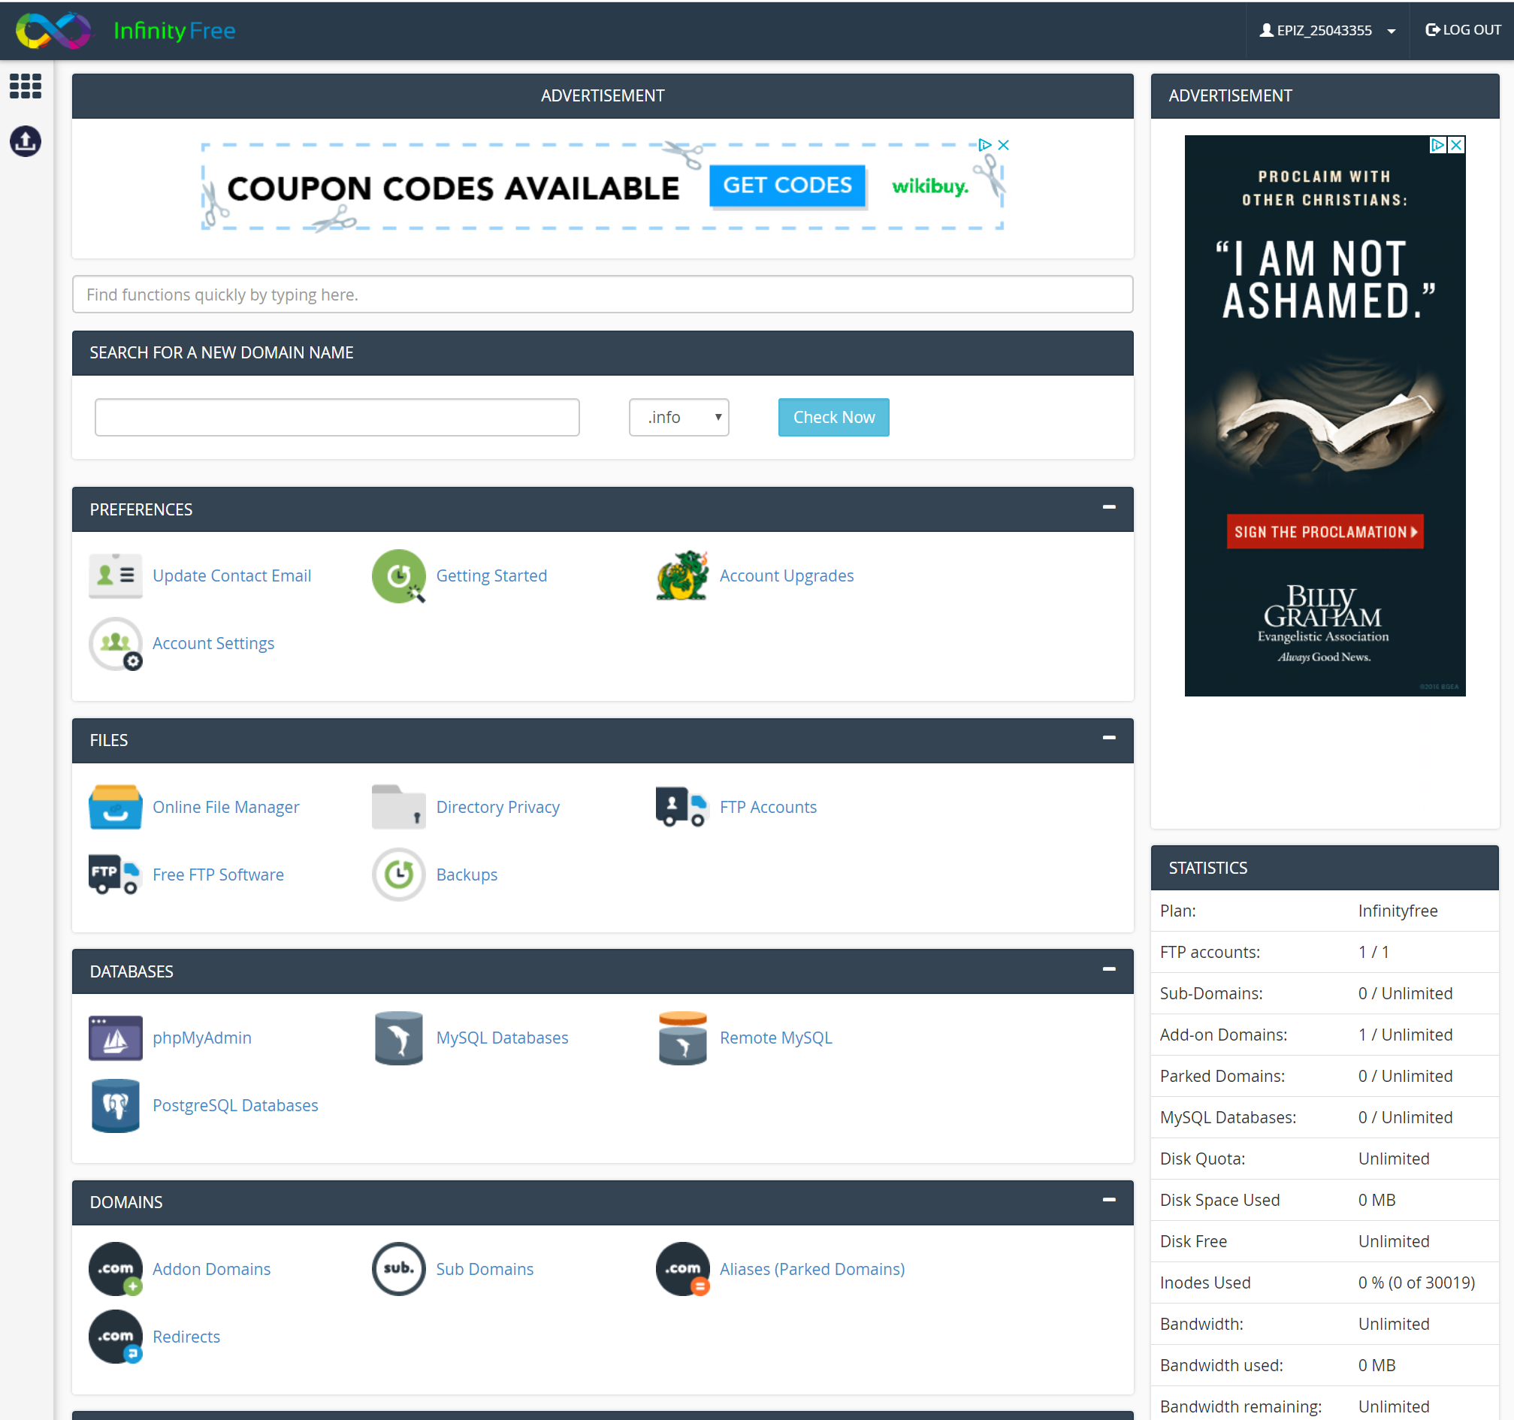

Verify your site is up

Verify your site is up with an incognito/ private window

Enter your site URL, Example:

If you get an error page try adding ‘www.’ to your URL

http://www.sp20djonesdcs.epizy.com

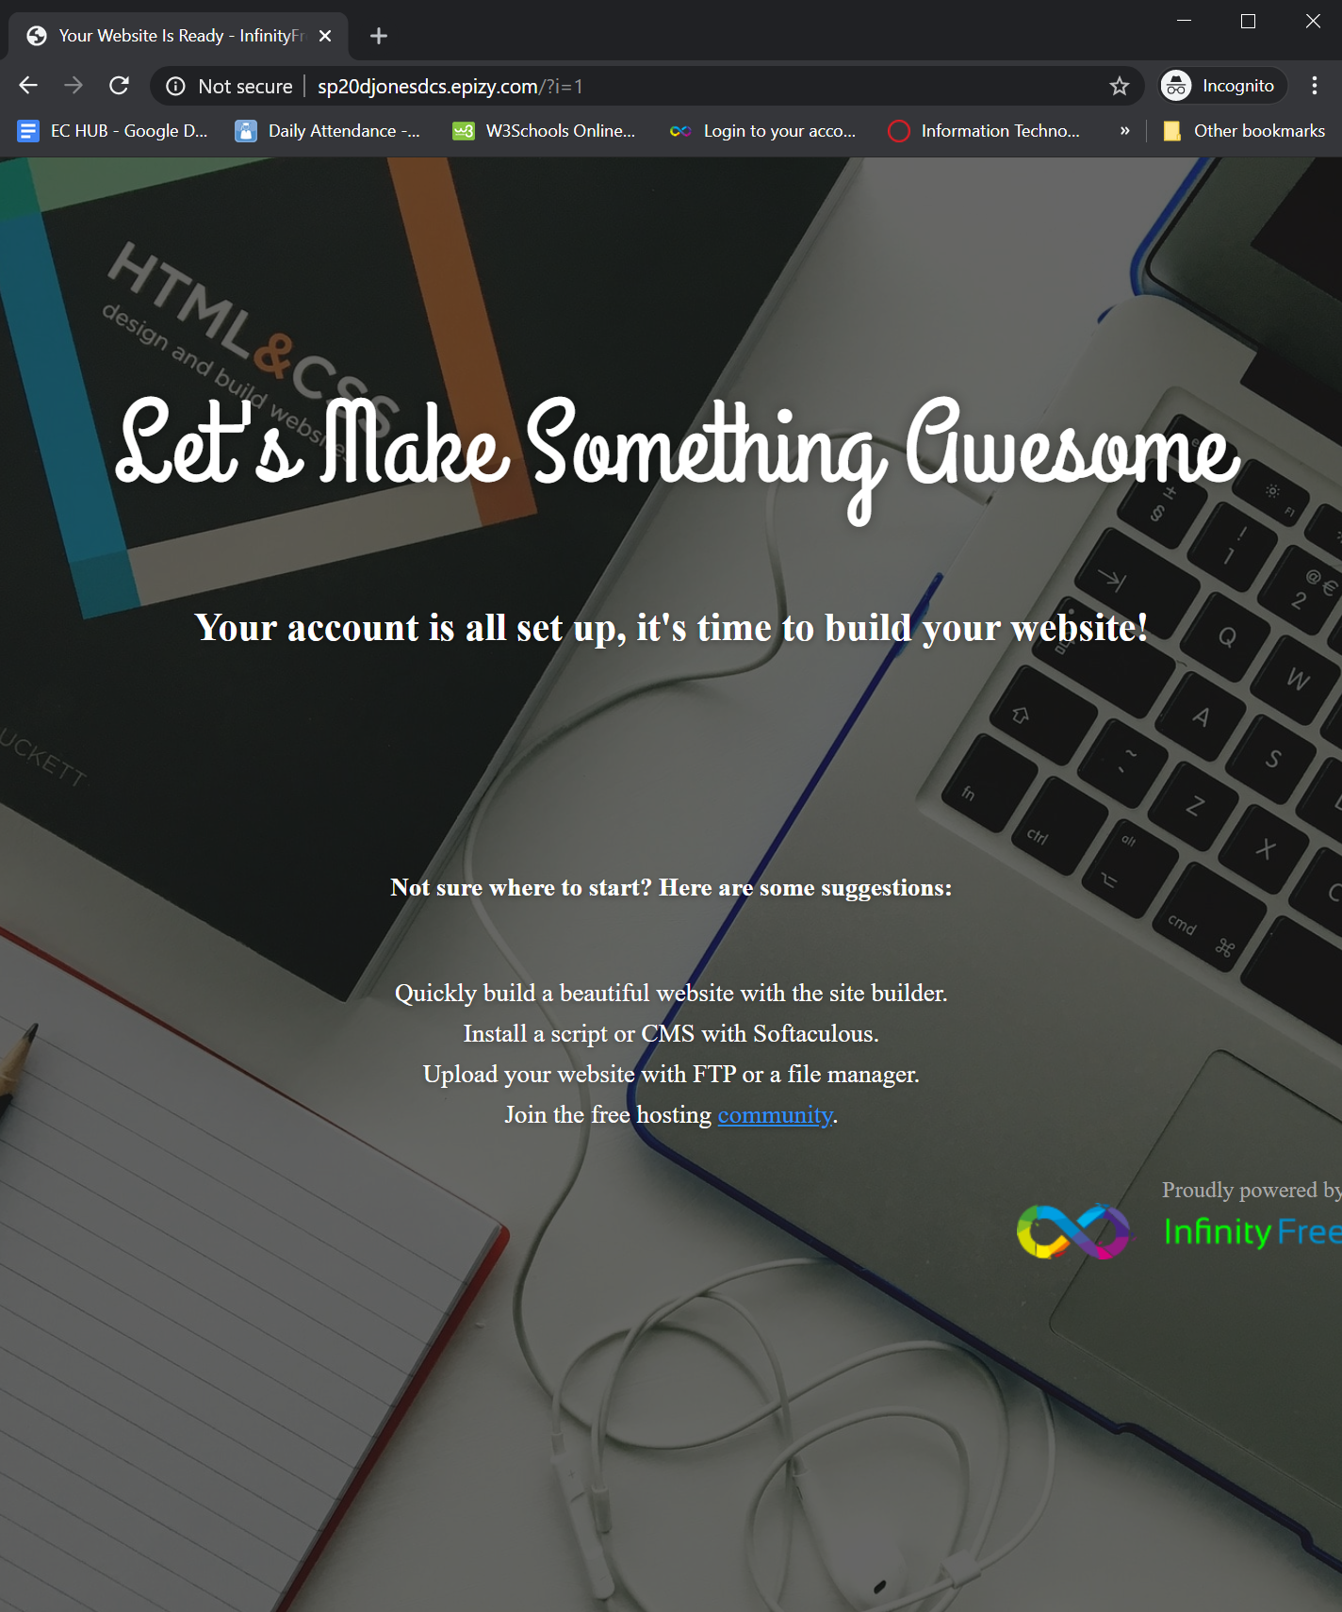

Your FTP Credentials

To find your FTP Password



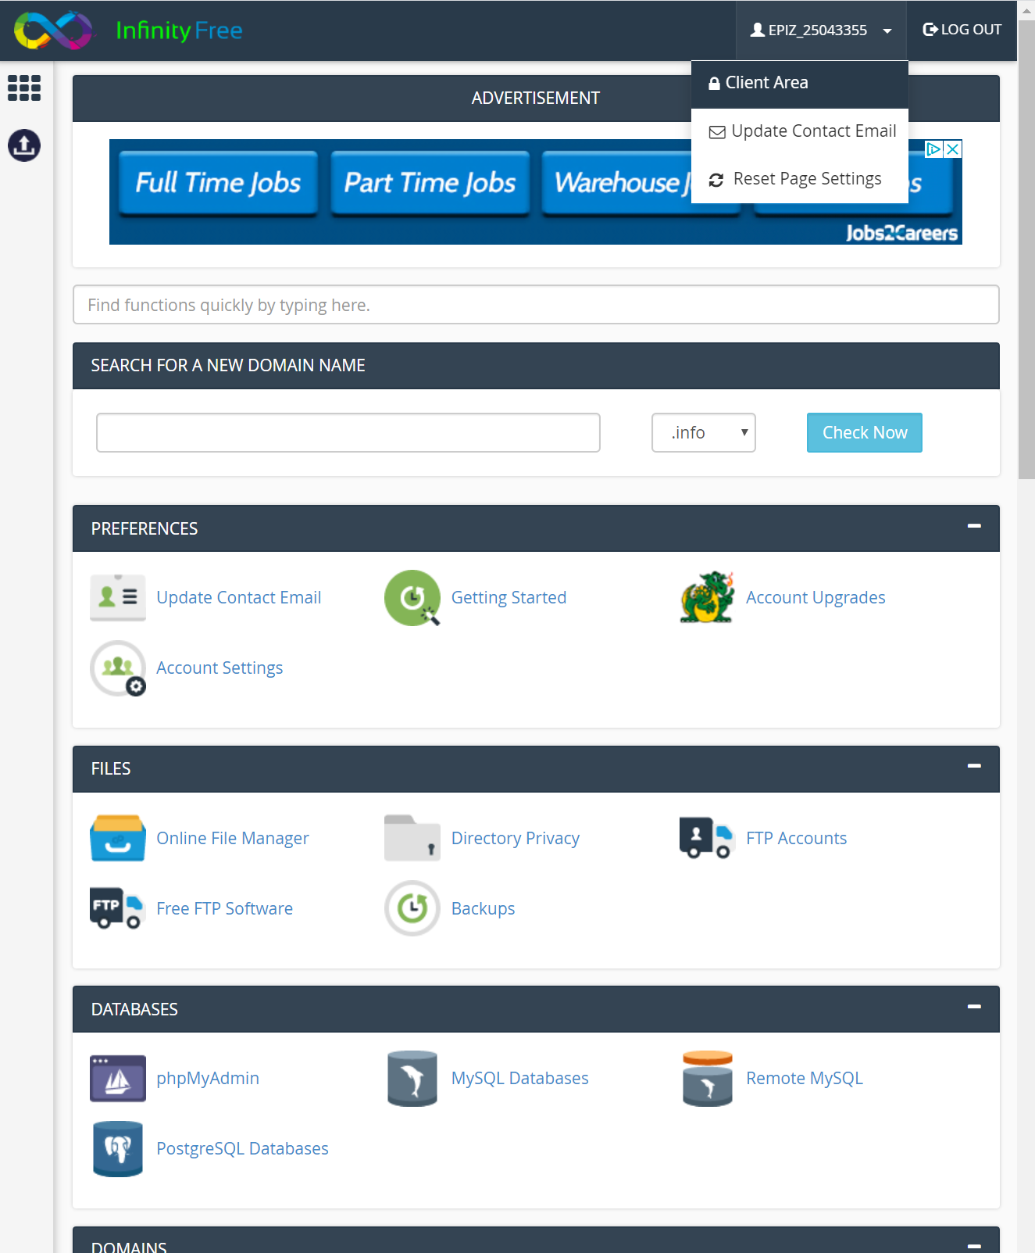

STOP!

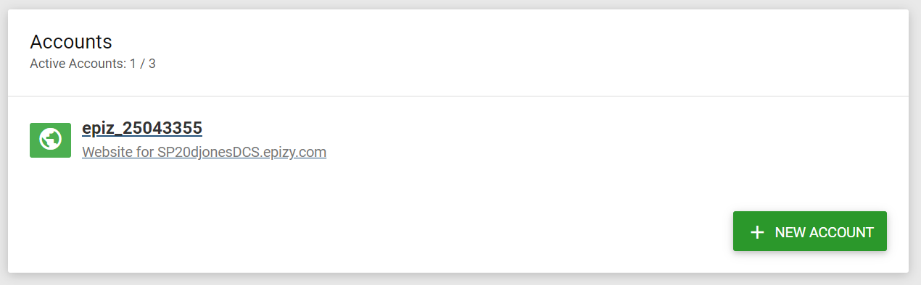

Click your account link NOT the “New Account” button



On the FTP Details Panel

Click the Show/Hide button

Note: This is your FTP password

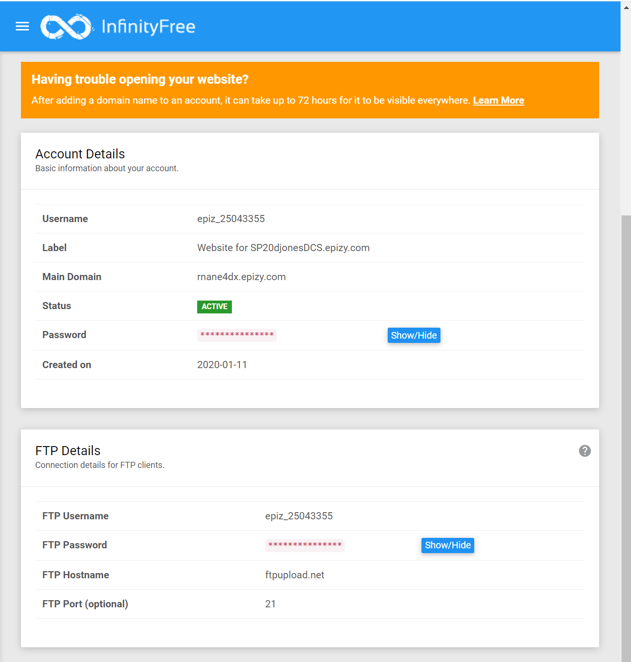

Managing Your Site, FTP Client

Open FileZilla

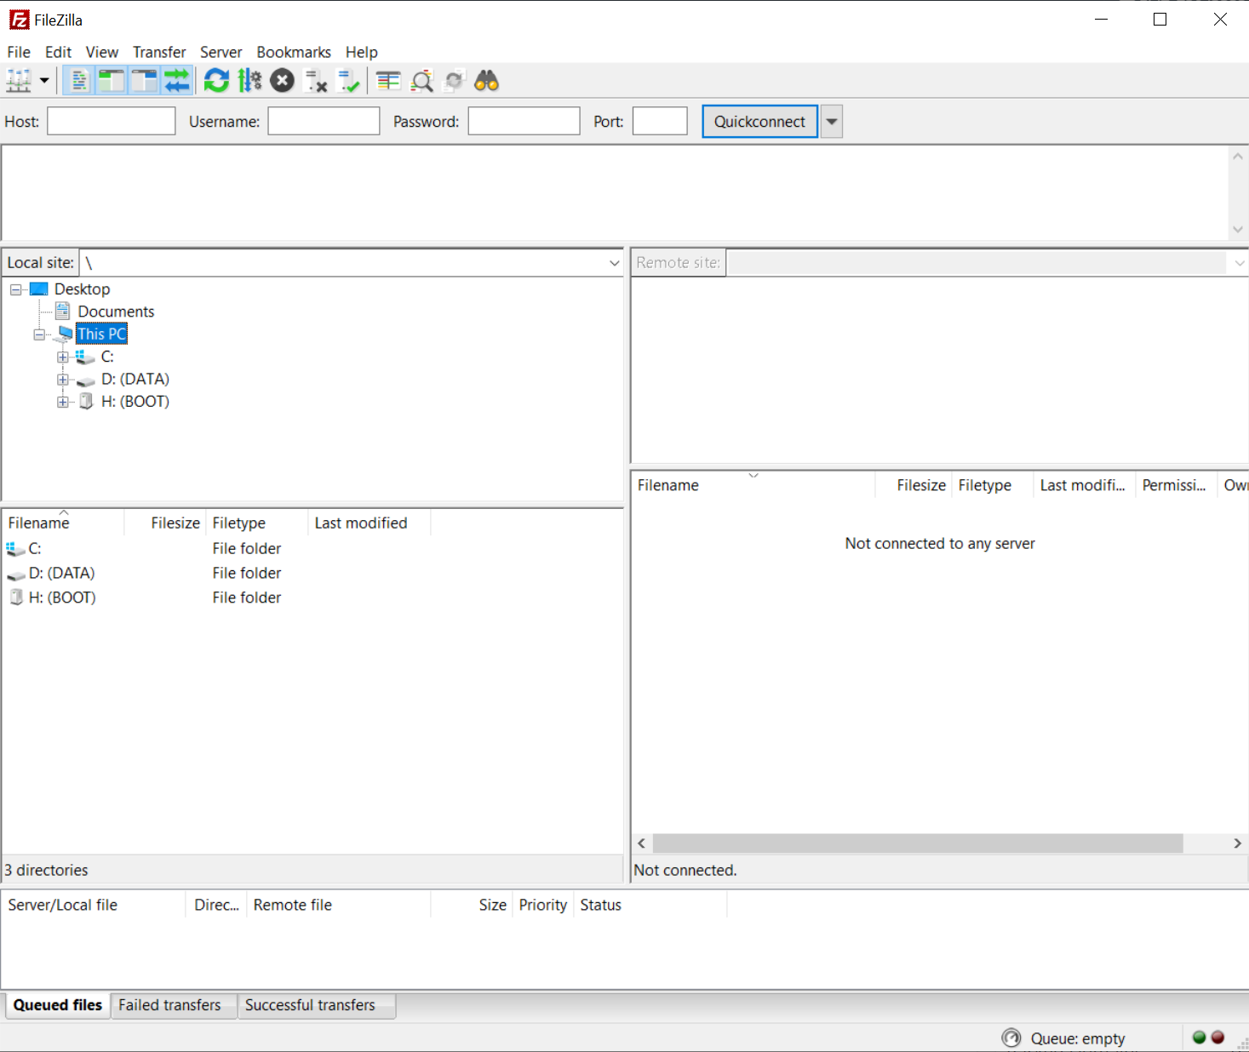

Click on “File” / “Site Manager”



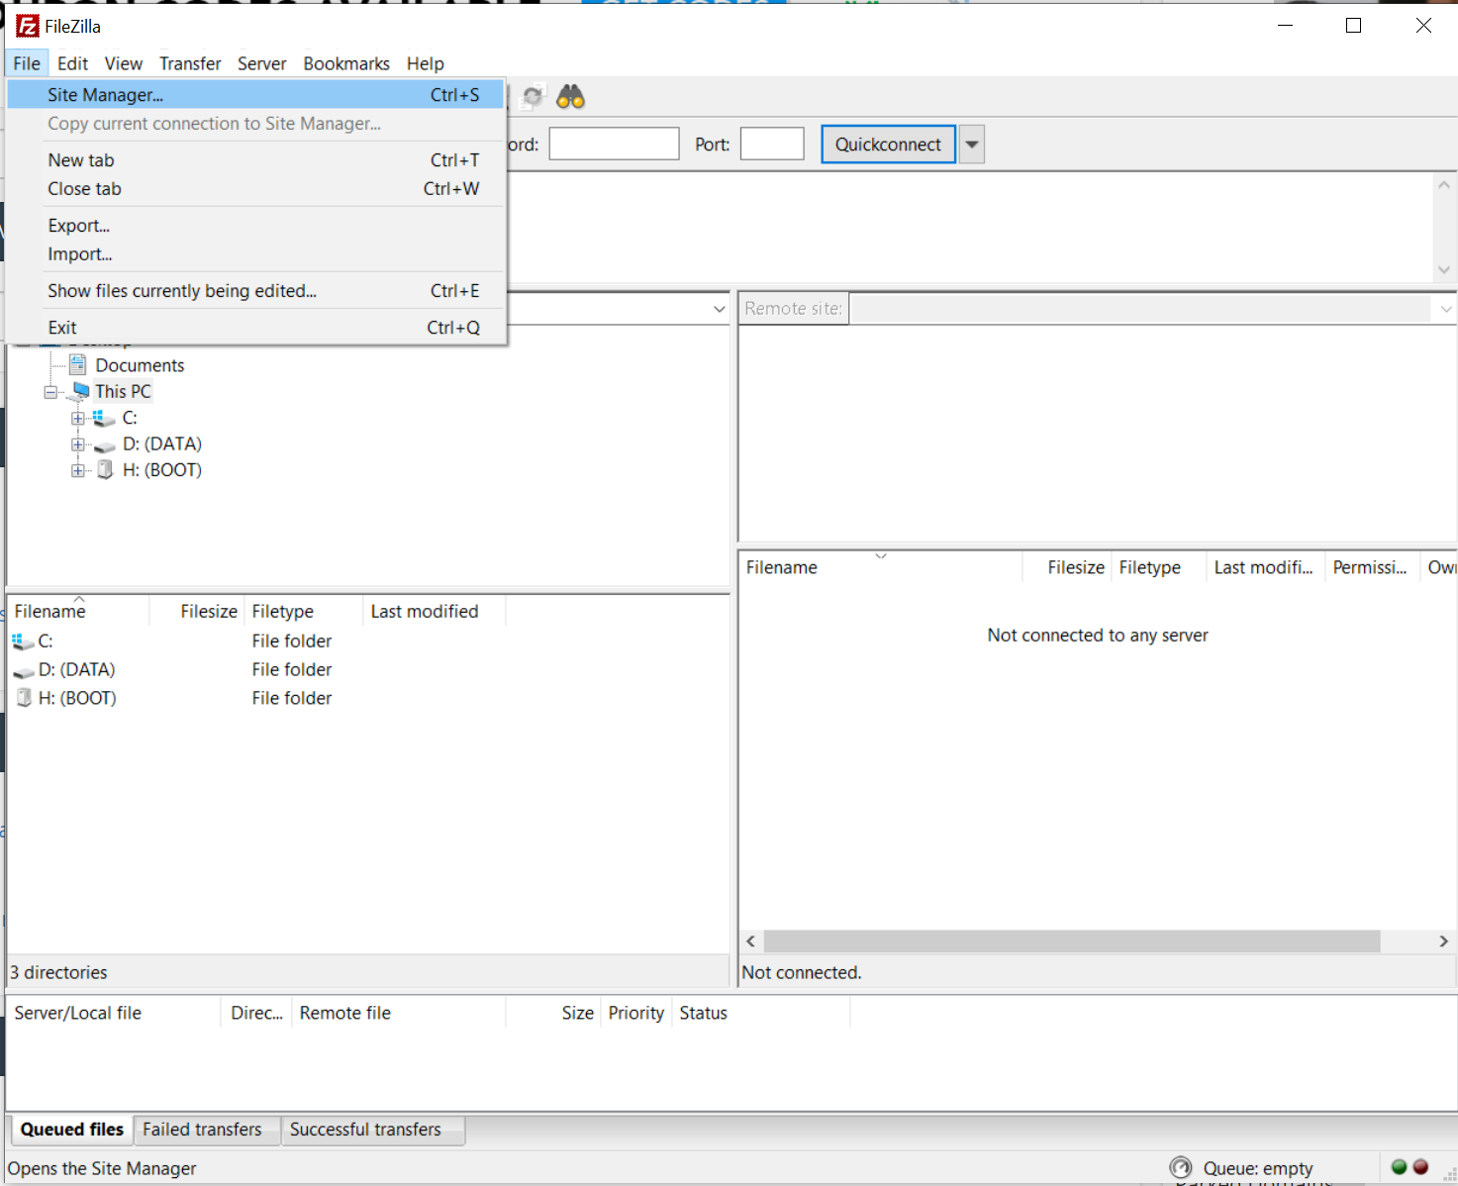

Click New site if an entry has not automatically been created

Enter your FTP Credentials

Click connect

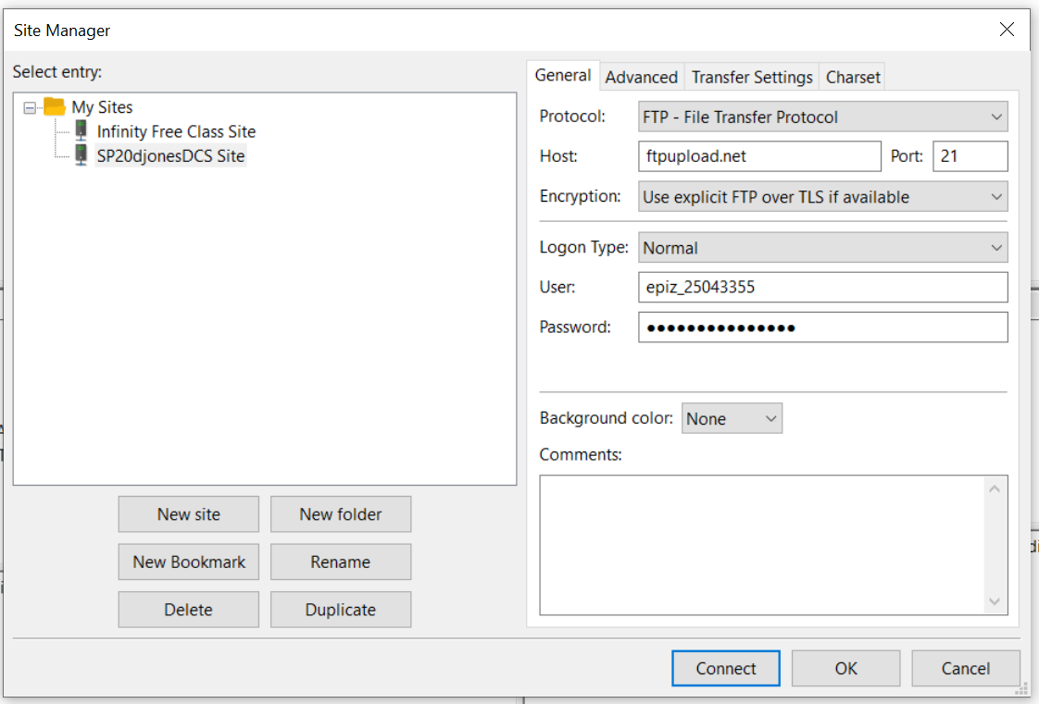

You should now be connected to your server directory

All files uploaded should be placed in the “htdocs” folder

